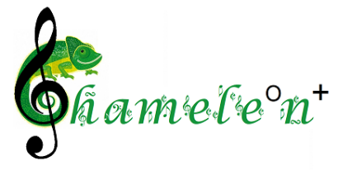
Chameleon+
2021-2022 International Competition
for Young Arrangers

APPLICATION FORM
The emblem:
Full name:

Date of birth:
Address:
Phone number:
E-mail:
The title of the chosen melody:
Category:(score/audiovisual recording)
Media: pdf/mp4/other

I hereby declare that I am fully acquainted and accept the Terms and Regulations of the Chameleon+ International Competition for Young Arrangers and all its Annexes.

………………....... ..............................................................................................................
Date Legible signature of the participant or the legal guardian of a minor participant

